Mission Support Application | 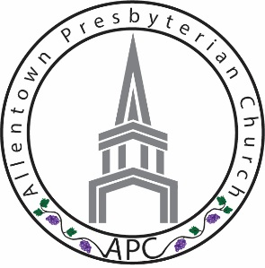

Contact Information
Name
Street Address
City ST ZIP Code
Home Phone
Cell Phone
E-Mail Address

The Mission Committee Work

It is the intent of the Mission Committee to support the work of our church family toward growing a community of fully devoted followers of Jesus Christ to produce abundant spiritual fruit for the Kingdom of God. To that end we have some funds set aside to assist people who are looking to serve in one of our mission fields and need some assistance in order to be able to attend. We cannot make any promises but will do our best to provide some assistance to further the work that these missionaries are doing to be able to serve.

The Process
The candidate needs to fill out the application and attach the two notes ( 2 ) and drop off in the mission committee drop box in the church office or give directly to Michelle Mallett ( for the Guatemala mission ) or Liz Heinzel-Nelson ( for the Malawi Africa mission ) to be considered for this year’s assistance program. Michelle or Liz will be in contact with you to set up a time for you to meet with them to review your application and to let you share your story.

The 2020 Missions

Guatemala 2016 Mission Trip – June 20 – June 27, 2020

Malawi Africa – March 6-14 (1st Medical Trip)
Malawi Africa - July 7-15 (1st Friendship Trip)
Malawi Africa – July 19-29 (2nd Medical Trip)
Malawi Africa – July 31-August 8 (2nd Friendship Trip)

Understanding the Goal

Which Mission trip are you looking to participate in
(Check the box)

Malawi Africa

Guatemala

Total cost of the trip? $_______________
Describe your fundraising efforts. ________________________________________________________

What is your request from the Mission Committee? __________________________________________

Your Calling

Please attach a note explaining your calling and how you came to decide to go on this trip. Please feel free to share with us your expectations of what the trip will offer you and what you plan to offer to the community to which you will be serving.

Your Faith Journey
Please attach a second note explaining where you are in your faith and how you feel this trip will allow you to grow in your faith and what you feel God is calling you to do in your faith journey.

Using our God-given gifts to build the Kingdom

